2026 Staff Art Exhibition Checklist
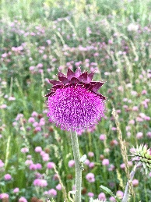
Naomi Adjei*
UNMC employee
Program Manager, Spirituality, Culture & Health Lab
Solitary Blossom
2026
photograph
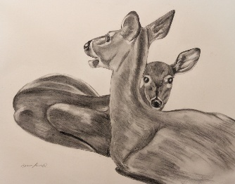
Homa Ahmed*
UNMC employee
Facilities Planner 1
Mother and Fawn
2026
graphite and charcoal pencil on paper
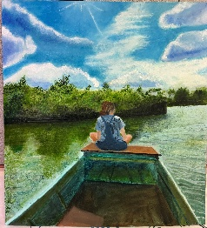
Alexis Beaudry
UNMC employee
Integrated Services Intern
Midday Drift
2026
oil crayon on paper
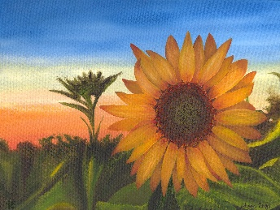
Megan Blusys*
UNMC employee
Director of Chancellor Communications
Where Hope Rises
2016
oil on canvas
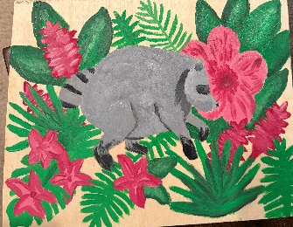
Janine Bogard
Nebraska Medicine employee
Critical Care Staff Nurse
Never Be Afraid to Be a Jimothy
2026
acrylic on plywood

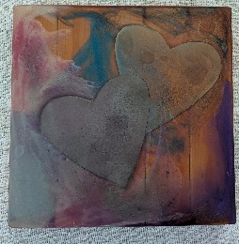
Jesse Boyd
UNMC employee
Funeral Director/Anatomy Education Specialist
Pith & Marrow
2022
wood, steel and resin

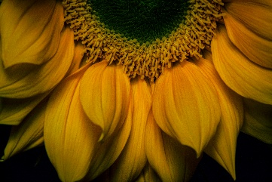
Deanna Brown*
Nebraska Medicine employee
Med Surg Staff Nurse
Sunflower
2026
photograph
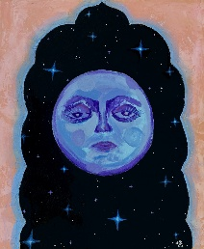
Madi Budin
UNMC employee
Administrative Projects Associate, Neurological Sciences
Moongaze
2026
acrylic and plaster on canvas
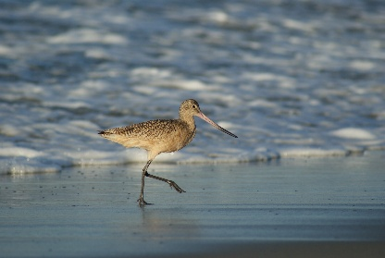
Karen Burbach*
UNMC employee
Director, Communications & Engagement, Strategic Communications
Along the Water’s Edge
2014
photograph
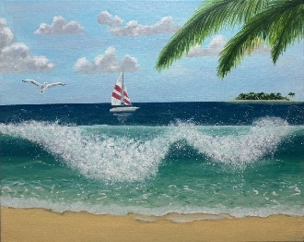
Carol Cal Concepcion
UNMC employee
Finance and Grants Specialist, Pediatrics
You & I in Paradise
2026
acrylic on canvas
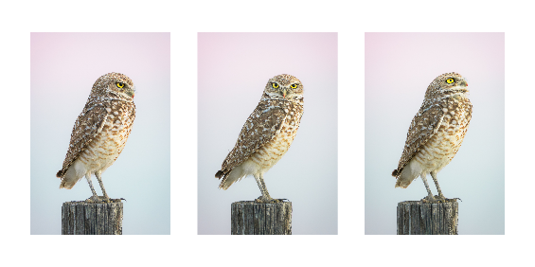
Yuka Collison*
UNMC employee
Autism Center Program Associate, MMI Pediatric Feeding
Looking into the Morning
2026
triptych photograph

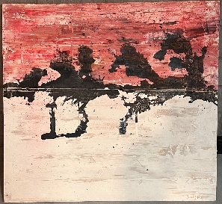
Jacob Dahlke
Nebraska Medicine employee
Ethics Director
Horizons
2010
acrylic, ink and plaster on canvas

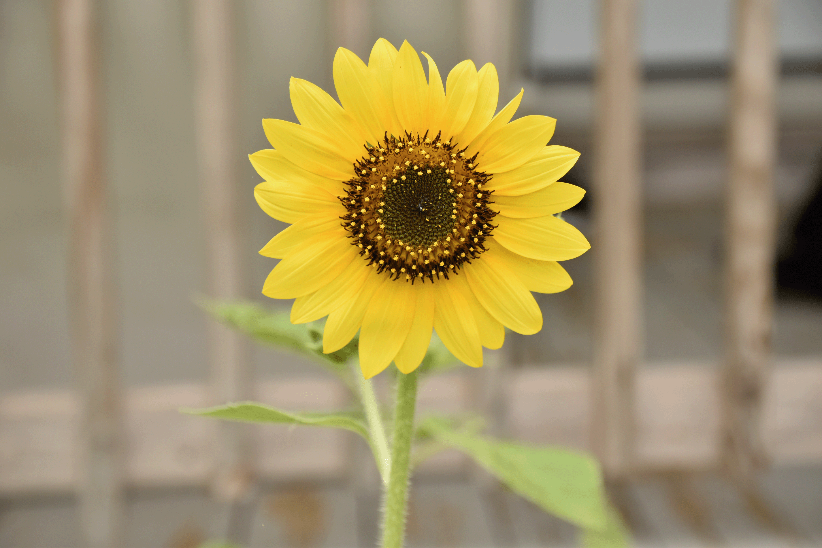
Amit Dash*
UNMC employee
Postdoctoral Research Associate, Pediatrics Hematology/Oncology
Growing toward the Light
2026
photograph on canvas
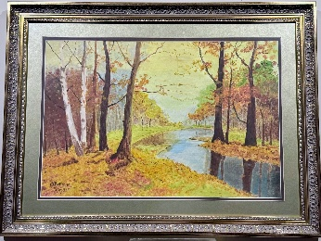
Bhavana J. Dave
UNMC employee
Former Professor, Pathology, Microbiology and Immunology
Bhavana
1981
painting on canvas

Dele Davies*
UNMC employee
Chancellor
Pico de Orizaba
2025
photograph
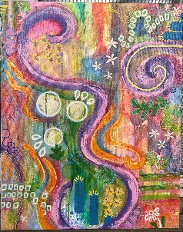
Liv Diggins
UNMC employee
Registered Behavior Technician, MMI Specialized Behavior Intervention Department
Living out Loud
2024
mixed media

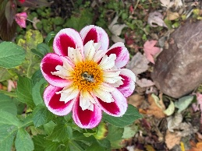
Amy Drayton
UNMC employee
Associate Professor, Munroe-Meyer Institute
Beez in the Trap
2025
photograph


Kelly Erickson
UNMC employee
Clinical Study Coordinator II, Child Health Research Institute
A Day in Vitre
2008
photograph

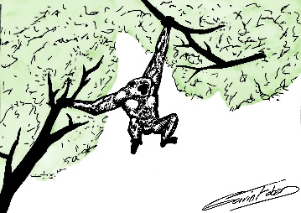
Gavin Faber
Nebraska Medicine employee
Retail Pharmacy Intern
Green Delight
2026
digital drawing
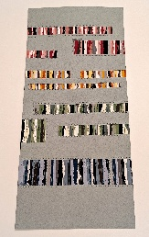
Madi Fishler*
UNMC employee
Student Services Coordinator, College of Pharmacy
Contained Motion
2026
paper and thread
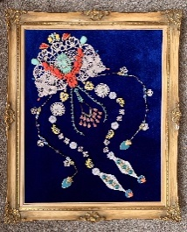
Hannah Fisk*
Nebraska Medicine employee
Certified Ophthalmic Assistant
Groovy Flow
2023
velvet, jewelry and doilies on canvas
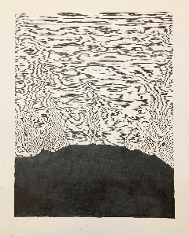
Kelsey Gall
UNMC employee
Assistant Administration Training Coordinator, MMI Specialized Behavior Intervention
Untitled 1
2018
pen and pencil on paper
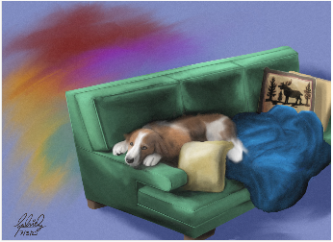
Gabriel Gauthier*
UNMC employee
Clinical Research Coordinator, Clinical Research Center
Take a Rest
2025
digital painting
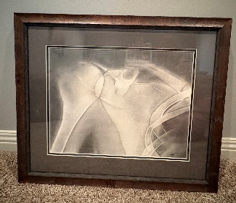
Kellie Gossman*
UNMC employee
Assistant Professor, Physical Therapy
Beneath the Surface
2006
charcoal on paper

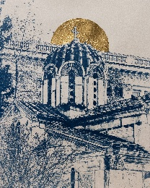
Annette Guy*
UNMC employee
Administrative Assistant I, Dean’s Office, College of Public Health
Take Me to Church
2026
cyanotype with gold leaf
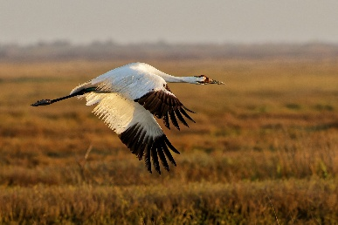
Jennifer Harmon*
UNMC employee
Office Assistant II, Obstetrics/Gynecology
Passage
2026
photograph
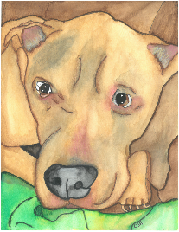
Carolyn Helmberger*
UNMC employee
Physical Medicine & Rehabilitation Coordinator
Wallace
2026
watercolor and colored pencil on paper
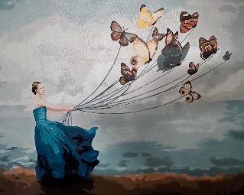
Kimia Hirbod*
UNMC employee
Graduate Research Assistant, COP Pharmaceutical Science
Wings of Freedom
2025
acrylic on canvas
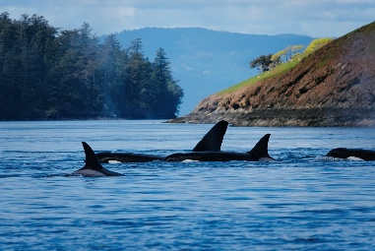
Jayme Hoch*
Dual Nebraska Medicine/UNMC employee
Palliative Medicine Physician
Family is Forever
2024
photograph

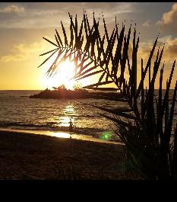
Sara Horner
Nebraska Medicine employee
Psychometrist
Golden Reflection
2016
photograph

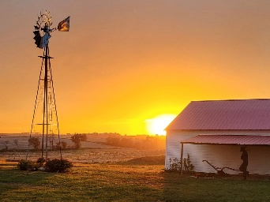
Amber Jackson*
Nebraska Medicine employee
Value Analysis Coordinator, Admin-Resource Control
Gentle Reminders
2026
photograph

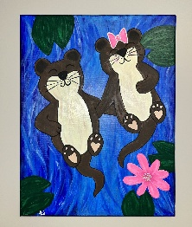
Kelly Johnson
UNMC employee
Environmental Compliance & Safety Specialist
Love One An Otter
2026
acrylic on canvas
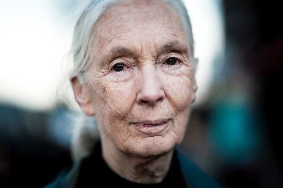
Atiim Jones*
UNMC employee
Lab Assistant III, Biochemistry
Jane Goodall
2016
photograph on acrylic face mount

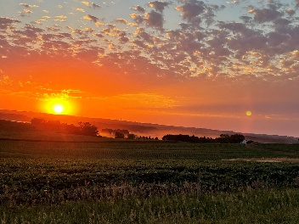
Tammy Jones*
UNMC employee
Research Nurse Coordinator
Summer Sunset in Iowa
2024
photograph
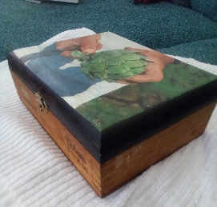
Daniel Kramer
Nebraska Medicine employee
Senior Retail Associate, Company Store
Harvest
2001
acrylic on wood
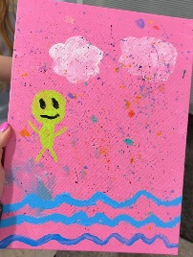
Sierra Krohn
Nebraska Medicine employee
Staff Nurse, Werner Infusion Center
The Voices Said Pink
2026
acrylic on canvas

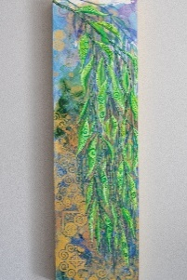
Der Lee
UNMC employee
Reimbursement/Account Representative, Pathology, Microbiology & Immunology
Willowing Essence
2026
acrylic on paper and masonite
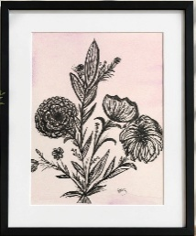
Colleen Liewer
Nebraska Medicine employee
MICU Nurse
Renewal
2026
drawing

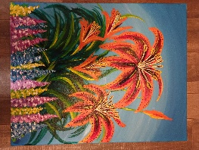
Michelle Lum*
UNMC employee
Research Instructor, Eppley Institute
Fire and Spires
2026
acrylic on canvas
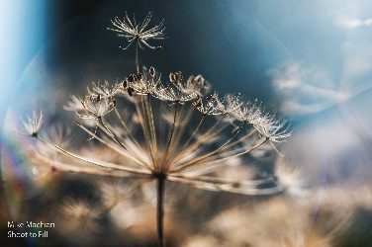
Mike Machian*
Nebraska Medicine employee
Multimedia Specialist, Marketing
Float on
2019
photograph
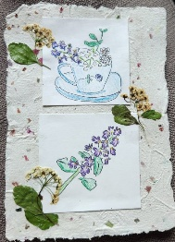
Patti Martin
UNMC employee
IT Project Manager
Second Chances
2026
pen and colored pencil on homemade paper

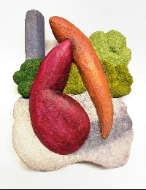
Thomas McLaughlin*
UNMC employee
Paraprofessional Arts Teacher, MMI
Post Environment 2
2026
acrylic and concrete on foam

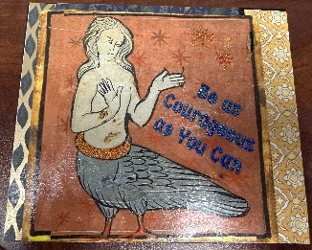
Catherine Medici-Thiemann
UNMC employee
Coordinator, Outreach Access and Resources, Student Success
A Siren Call to Courage
2025
paper collage on wood with crystal
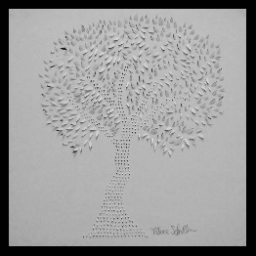
Pallace Messer*
UNMC employee
Education & Training Program Coordinator, Eppley Institute
Branches of Hope
2011
cut paper
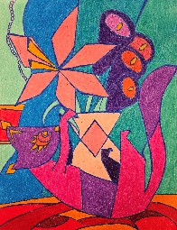
Emily Miller*
UNMC employee
Job Coach, MMI UCEDD
untitled
2025
colored pencil on paper
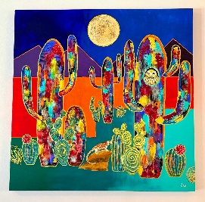
Jami Monico*
UNMC employee
Instructional Designer, Obstetrics/Gynecology
Arizona Desert at Night
2025
acrylic on canvas
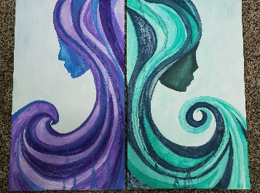
Danielle Muhle
Nebraska Medicine employee
Senior Associate Patient Coordinator, Heart Transplant
Okeanos & Petrichor
2019
watercolor pastel on cardstock

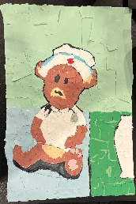
Rachel Mulligan
UNMC employee
Student Peer Mentor, MMI UCEDD
Nurse Teddy Bear
2026
torn paper

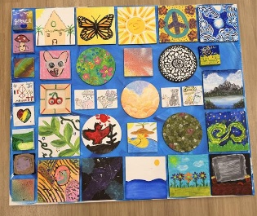
Munroe-Meyer Institute Specialized Behavior Intervention Department
UNMC employees
A Collection of Joys
2026
acrylic and canvas
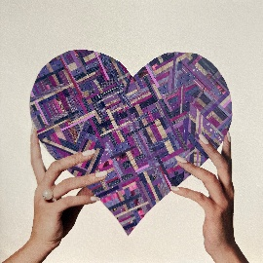
Kellie Osler*
UNMC employee
Experiential Programs Associate, College of Pharmacy
Healing Hands
2025
paper collage
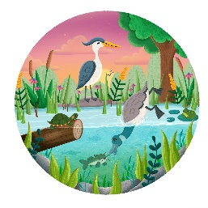
Megan Pohl*
Nebraska Medicine employee
Respiratory Therapist, Pulmonary Lab
Sunset Splash
2026
digital illustration
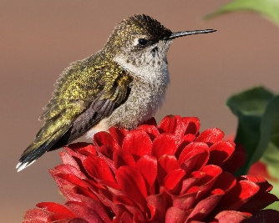
Cecelia Poon*
Nebraska Medicine employee
Clinical Psychologist
Unfazed
2025
photograph
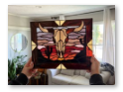
Julia Quiqley*
UNMC employee
Applied Practice Manager, College of Public Health
Southwest Sunset
2025
stained glass

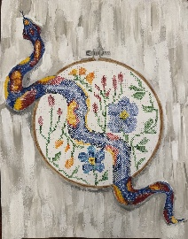
Lizz Reese
UNMC employee
Genetic Counselor, MMI Genetic Medicine
Look Again
2026
acrylic on toned paper

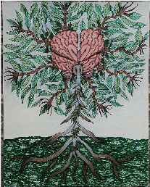
Svetlana Romanova*
UNMC employee
Research Assistant Professor, College of Pharmacy
Tree of Life
2026
Sharpie and colored pencil on paper
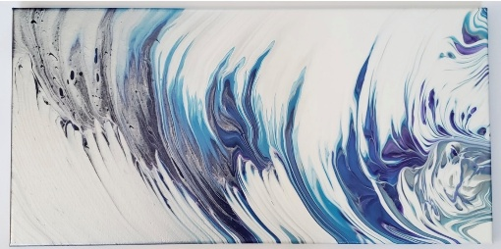
Katina Russ*
Nebraska Medicine employee
Med Surg Staff Nurse
Fly on My Wall
2021
craft paint on canvas
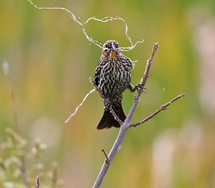
Allie Scamardo*
UNMC employee
Post Approval Compliance Coord/Liaison, Office of Animal Care
Threads of Hope
2026
photograph
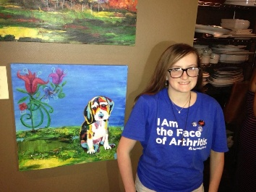
Julia Schmidt
Nebraska Medicine employee
Medical Receptionist, Nebraska Cardiac Care Clinic
Patchwork Puppy
2013
acrylic and oil pastel on canvas

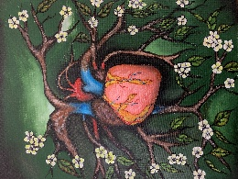
Carlos Serna*
Nebraska Medicine employee
Lab Support Assistant, Anatomic Pathology
Nature’s Heart
2025
acrylic on canvas
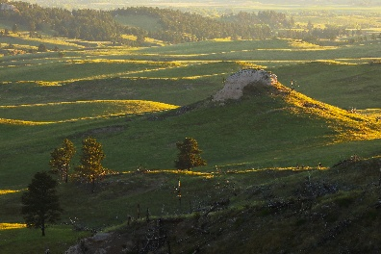
Hamid Shahshahan*
UNMC employee
Research Technologist II, Cellular/Integrative Physiology
Forest Edge Sunrise
2023
photograph on metal

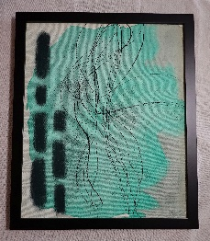
Jill Skorupa
UNMC employee
Research Nurse Coordinator, Neurosurgery
Celadon Zephyr
2026
watercolor, acrylic, ink and pastel on canvas
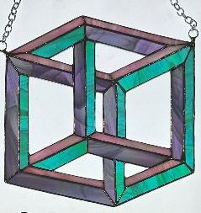
Emma Skow*
Nebraska Medicine employee
Administrative Senior Assistant, Clinical Quality
Do the Impossible
2026
stained glass
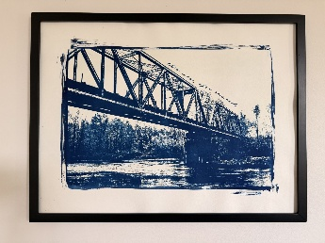
Emma Smith*
Nebraska Medicine employee
Organizational Development Consultant
This Way, Then Onward
2026
cyanotype on watercolor paper
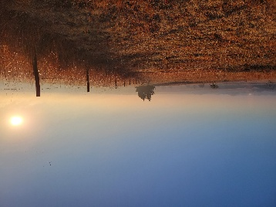
Josh Souchek*
UNMC employee
Assistant Professor, Biochemistry & Molecular Biology
Foggy Pasture
2024
photograph
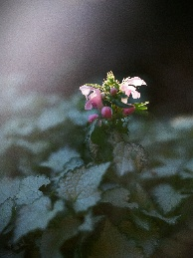
Joanna Spaulding*
UNMC employee
Assistant Professor, MMI Genetic Medicine
Even Here
2012
photograph

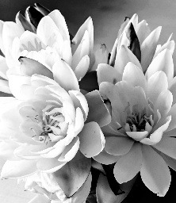
Molly Stirek*
Nebraska Medicine employee
Nutrition Therapist
Hope Floats
2025
photograph

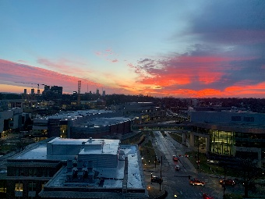
Elizabeth Stone*
UNMC employee
Research Technologist I, Anesthesiology
Quiet Beginnings
2024
photograph
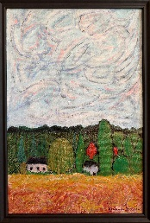
Hillman Terzian*
Dual Nebraska Medicine/UNMC employee
Acute Care Surgeon
Beneath the Turning Sky
2026
acrylic on canvas
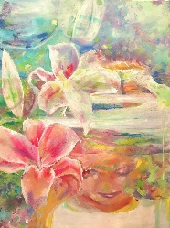
Kara Walters*
UNMC employee
Intern/Student Worker, McGoogan Health Sciences Library
Self-Portrait
2025
oil on canvas
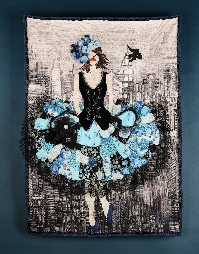
Sue Welch
UNMC employee
Academic Services Coordinator
Sofie
2026
fabric quilt
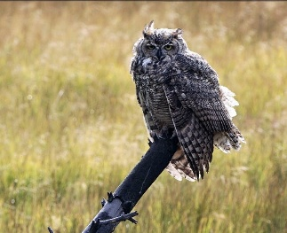
Kellie Wiegand*
Nebraska Medicine employee
Radiation Therapist
Great Horned Owl at Yellowstone National Park
2025
photograph
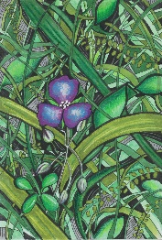
Hannah Winchester*
UNMC employee
Education & Research Services Librarian, McGoogan Health Sciences Library
Tangle
2025
pen, marker and colored pencil on paper

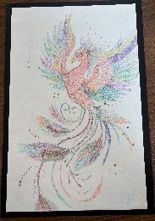
Elise Zietz
UNMC employee
Trailblazer Program Job Coach, MMI UCEDD
Kane’s Imaginarium
2026
colored pencil on cardstock

*indicates artwork will be included in the physical art exhibition at BCC

